***Assignment - 1 Submission By A.Anandhabala***

1. Use the installation guide, to set up your system for performing the Tableau practical. Refer to the Installation Guide in “Installation Guide – Tableau-10.0” section with the file named “Installation Guide”:

Ans:

Steps:

* download the Tableau Desktop use this link.
* https://www.tableau.com/products/desktop/download .
* 
* Click the free student licence.
* Fil the forms for license. To activate the Tableau .
* You add some proof example id card.
* You get a mail for product key from the tableau envirnment.
* 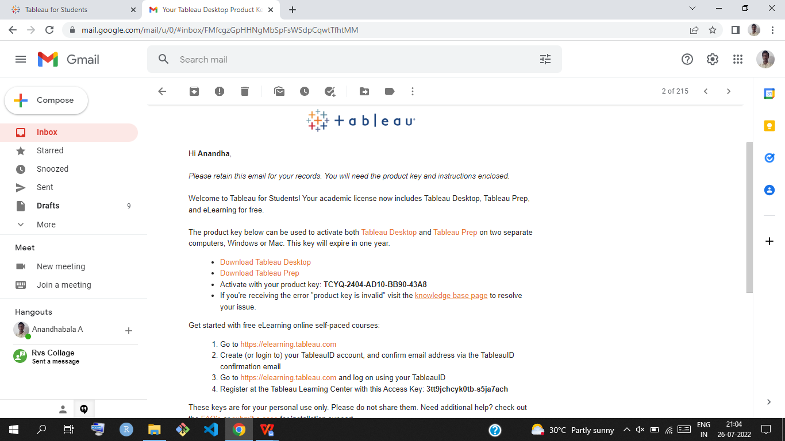
* Download and install the Tableau use This mail.
* After installing its ask Free trial or Activate.
* Click Activate ,its ask product key that time your mail is have some product key

you copy and paste .its shows.

* Its displays the SUCCESSFULLY ACTIVATED.
* Click continue .the installation of a Tableau Desktop is completed.
* 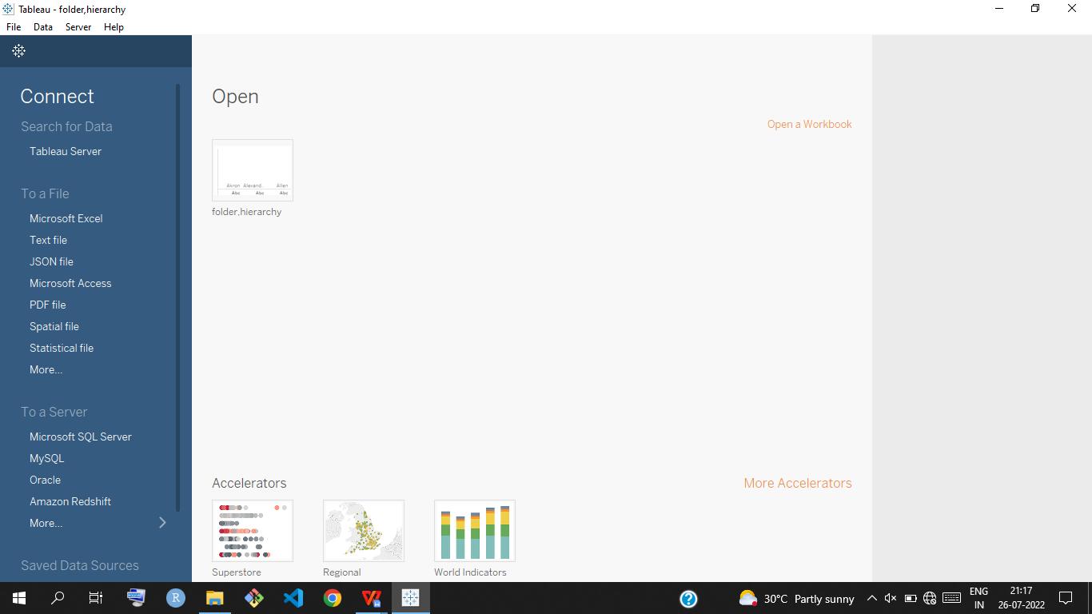
* Complted the installation of Tableau DESKTOP.

1. Download the data – set (sales – product) from the link:

Establish the connection between tableau and data-set.

Perform left join, right join, cross joins between sales and product data-set

Note the difference between them joins in terms of data – set and visualization and compile them in a word document.

Ans:

Steps:

* Open the tableau public .
* Connect the two data sets of sales and product.
* Perform the left join,right join,cross join:
* CROSS JOIN :(category,sub-category from product data set),(orderdate,sales from sales data)

Ans:

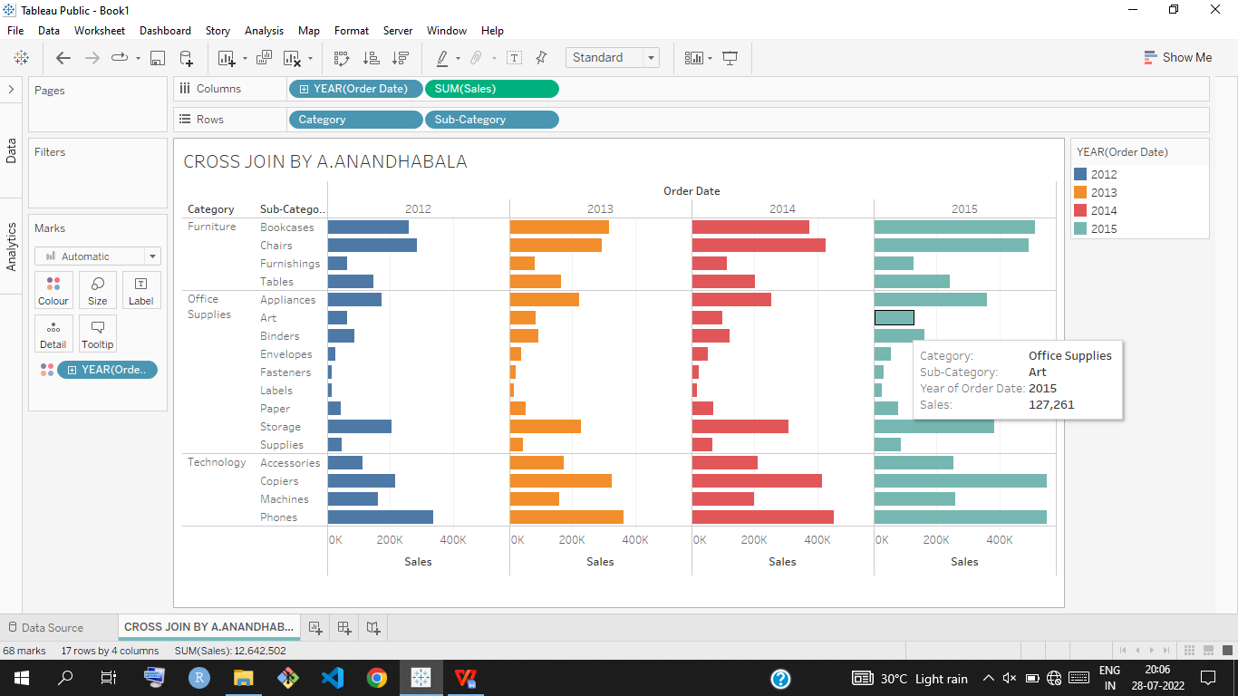

* Left join: (product id ,sales from sales data set) (product name,sub-category from product data set)

Ans:

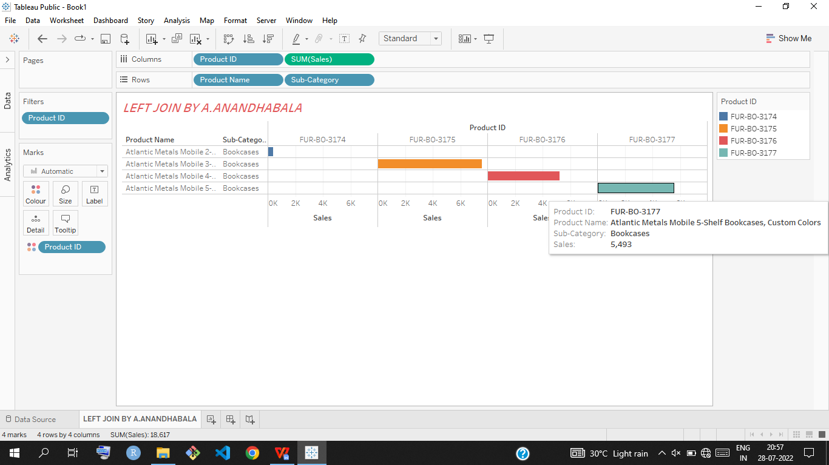

* Right join: (sales ,market,order date from sales data set) (product- id from product data set).

Ans:

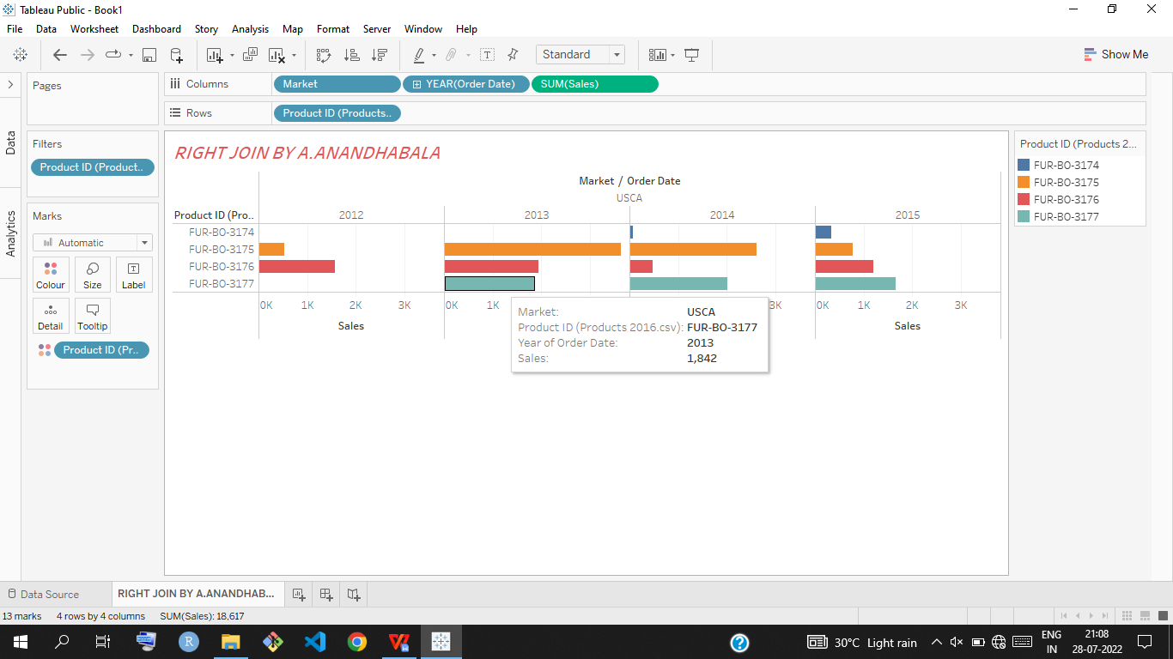

CODING ASSIGNMENT 1.1

SUBMISSION BY

A.ANANDHABALA